Git and Binary Files

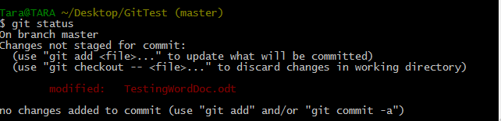

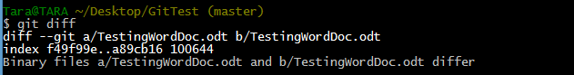

$ ls – to view all
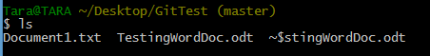

$ log – [filename] To get commit history of file => different versions

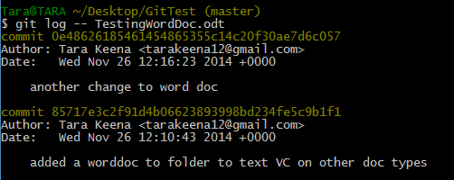

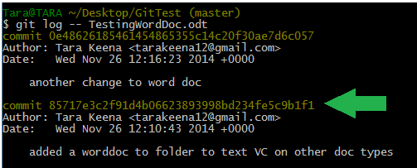https://github.com/tkeena/GitTester.git

https://github.com/tkeena/GitTester.gitgit gitgit agt

